**Lab2:**

**13-Create a folder called myteam in your home directory and change its permissions to read only for the owner**:

mkdir ~/myteam

chmod 400 ~/myteam

**14-Log out and log in by another user**

Log out: exit

Login: su username

passwor

**15-Try to access (by cd command) the folder (myteam)**

cd ~/myteam

**16-Using the command Line**

• Change the permissions of oldpasswd file to give owner read and write permissions and for group write and execute and execute only for the others (using chmod in 2 different ways)

chmod u=rw,g=wx,o=x oldpasswd

chmod 620 oldpasswd

• Change your default permissions to be as above.

umask 035

• What is the maximum permission a file can have, by default when it is just created? And what is that for directory.

max permissions for file 666, for directory 777

• Change your default permissions to be no permission to everyone then create a directory and a file to verify.

umask 777

mkdir dir

touch Nf

**17-What are the minimum permission needed for:**

**• Copy a directory (permission for source directory and permissions for target parent directory)**

**Source Directory**: Execute and read permission

**Source Files**: Read permission

**Target Directory**: Execute and write permission

**• Copy a file (permission for source file and permission for target parent directory)**

Source File: Read permission

Target Directory: Execute and write permission

**• Delete a file**

Write and execute permission

**• Change to a directory**

Execute permission

**• List a directory content (ls command)**

Read and execute permission

**• View a file content (more/cat command)**

Read permission

**• Modify a file content**

Modify a file content: Write permission

**18-Create a file with permission 444. Try to edit in it and to remove it? Note what happened.**

touch file.txt

chmod 444 file.txt

echo "new line" > file.txt

file.txt: Permission denied

rm file.txt

file removed !

**19-What is the difference between the “x” permission for a file and for a directory**

File:the “x” permission means the file is **executable**

Directory: means you can access this directory

**Lab 3:**

**1-** . **Using vi write your CV in the file mycv. Your CV should include your name, age, school, college, experience,...**

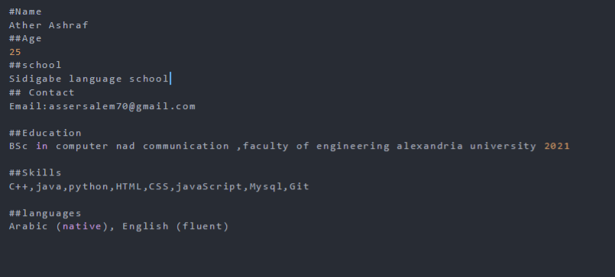

**2-Open mycv file using vi command then: Without using arrows state how to:**

**a. Move the cursor down one line at time.**

j

**b. Move the cursor up one line at time.**

k

**c. Search for word age**

/age

**d. Step to line 5 (assuming that you are in line 1 and file is more than 5 lines).**

5g

**e. Delete the line you are on and line 5. f. How to step to the end of line and change to writing mode in one-step.**

Dd

5g dd

**3-List the available shells in your system**

cat /etc/shells

**4-List the environment variables in your current shell**

printenv

**5-List all of the environment variables for the bash shell**

printenv

**6-What are the commands that list the value of a specific variable?**

Echo variable name

Set | grep variable name

Printenv variable name

**7-display your current shell name.**

echo $0

**8-State the initialization files of: sh, ksh, bash**

Sh: [/etc/profile](https://tldp.org/LDP/Bash-Beginners-Guide/html/sect_03_01.html)

Ksh: [/etc/profile](https://tldp.org/LDP/Bash-Beginners-Guide/html/sect_03_01.html)

Bash: [/etc/profile](https://tldp.org/LDP/Bash-Beginners-Guide/html/sect_03_01.html), [/etc/bash.bashrc](https://tldp.org/LDP/Bash-Beginners-Guide/html/sect_03_01.html), [~/.bash_profile](https://stackoverflow.com/questions/6372751/what-is-the-difference-between-the-various-shell-profiles), [~/.bashrc](https://stackoverflow.com/questions/6372751/what-is-the-difference-between-the-various-shell-profiles)

**9-Edit in your profile to display date at login and change your prompt permanently.**

Open ~/.bash_profile file

Add echo “Login time: $(date)”

Save and exit

Source ~/.bash_profile

Change the value of PS1 in ~/.bashrc file

Save and exit

Source ~/.bashrc

**10-Execute the following command : echo \ then press enter What is the purpose of \ ? Notice the prompt ”>” what is that? and how can you change it from “>” to “:”.**

[(\) is used as an escape](https://phoenixnap.com/kb/echo-command-linux)

(>)is the shell prompt. It’s a symbol at the start of the command line. [It’s waiting for](https://vitux.com/how-to-customize-ubuntu-bash-prompt/)a command input

[modify the PS1 environment variable in ~/.bashrc file](https://vitux.com/how-to-customize-ubuntu-bash-prompt/)

Change the '>' to ':'

Then run: source ~/.bashrc In the terminal

**11-Create a Bash shell alias named ls for the “ls –l” command**

Open ~/.bashrc file

Add this line:

Alias ls =’ls -l’

Save and exit

Run source ~/.bashrc